3D Weather in the Classroom

**Blizzard**

**1.Overview**

What is a blizzard? The National Weather Service defines a blizzard as a severe snowstorm characterized by strong winds causing blowing snow that results in low visibilities. The difference between a blizzard and a snowstorm is the strength of the wind, not the amount of snow. Winds in a blizzard must be greater than 35 mph with visibility of less than ¼ mile for at least three hours. Some blizzards can have wind speeds as strong as a category 1 or category 2 hurricane.

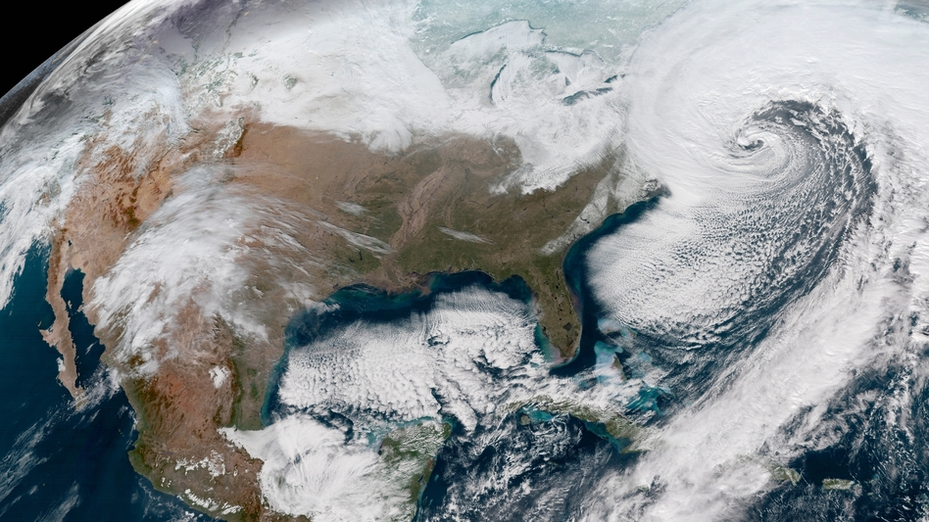

Figure 1: Satellite imagery of snowfall due to a blizzard in the Northern United States.

Blizzards can happen in many locations throughout the world. The most common locations are Russia, central and northeastern Asia, northern Europe, Canada, northern United States, and Antarctica. For the United States, blizzards are most common in the upper Midwest and the Great Plains.

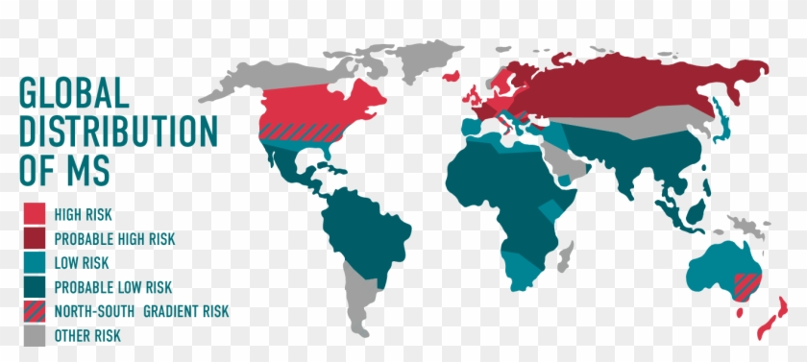

Figure 2: Global distribution of areas that are at risk of experiencing a blizzard.

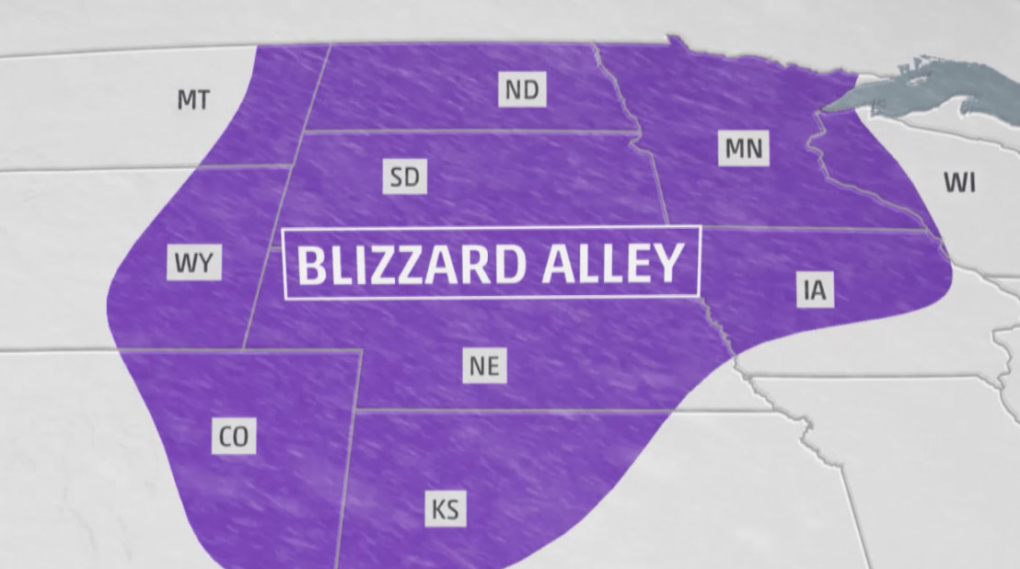

Figure 3: Areas in the United States that are known to experiences blizzards.

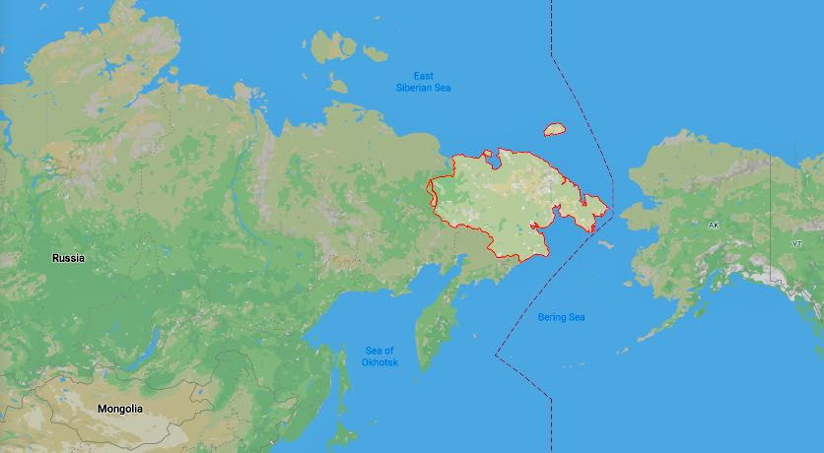

Figure 4: This region is known as Chukotka, Russia and is commonly known to experiences blizzards.

In order for a blizzard to form, it needs three things:

1. **Cold air**

For snow to accumulate on the ground, the temperature must be cold both in the atmosphere (where snow forms) and on the ground. If the air near the ground or the ground temperature is too warm, the snow will melt as it falls through the atmosphere and not stick to the ground.

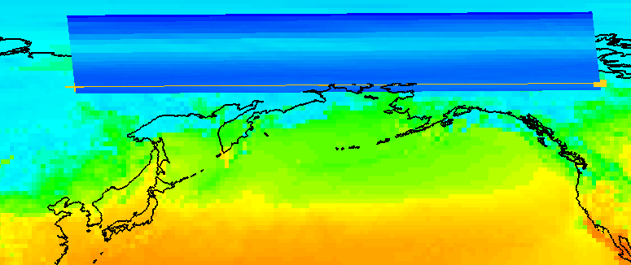

Figure 5: IDV image of surface temperature and corresponding vertical temperature profile.

1. **Moisture**

Moisture in the air is commonly known as water vapor and it is needed to form clouds and precipitation. For cold conditions, air blowing across a body of water (a lake or the ocean) is a common source of water vapor.

As wind blows over the water, some water evaporates from the surface allowing water vapor to enter into the atmosphere. Wind blowing over lakes leads to lake effect snowstorms or Nor’easters. Cold air is not able to hold much water vapor, so air below freezing does not make much snow.

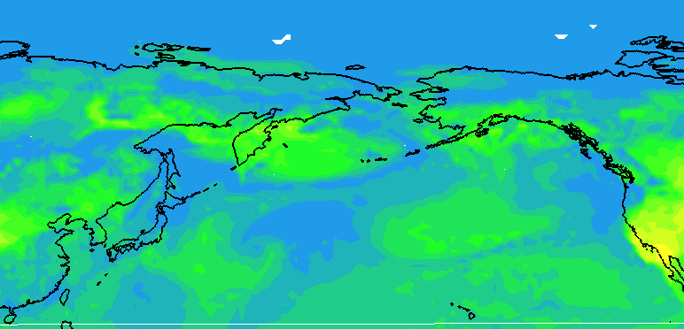

Figure 6: IDV image of Relative Humidity which shows the moisture of the atmosphere.

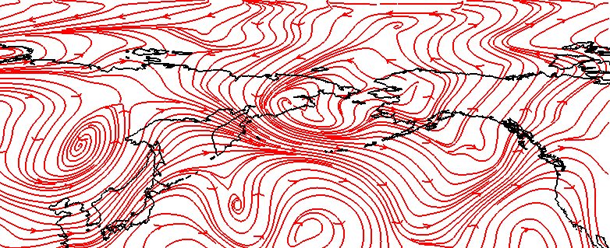

Figure 7: IDV image showing 300mb streamlines.

1. **Moist air must rise over cold air.**

As wind blows, cold air can be pushed towards the equator from the poles and can bring warmer, moist air towards the poles from the equator. When cold and warm air masses are brought together, a front is formed, and snow can form if the cold air is cold enough.

Even though a blizzard looks beautiful in photos, blizzards can be extremely dangerous to experience. Blizzards are extremely dangerous because of the blinding snow. Strong winds can create a cold wind chill, making the temperature feel even colder. Blizzards create a high risk of frostbite, car accidents and much more.

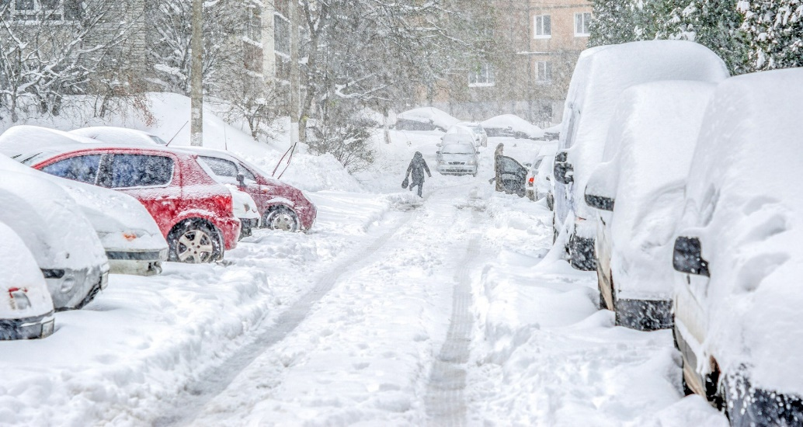

Figure 8: Blizzard conditions at ground level.

1. **IDV Project**

Project filename: “Blizzard.xidv”

* Project data:
  + Filename: “gfs_3_20210930_0000_000.grb2”
  + 0.25°x0.25° Global Forecast System (GFS) analysis data for September 30, 2021 @ 00:00Z.
* Displays:
* Maps
* World country outlines.
* Plan views
  + - * Surface temperature
      * Surface relative humidity
    - Cross Sections
      * Temperature (°C)
    - Flow Displays
      * 300 mb streamlines.

Features to note:

* Figures 5 and 6 shows that even though the temperatures for Russia are very cold, there is still a fair amount of moisture in the atmosphere.
* Figure 7 shows streamlines of the wind coming from the north bringing cooler temperatures to the area. These wind speeds are also showing strong winds which are needed for the storm to be considered a blizzard.

**3. Knowledge Requirements**

* Module 1-1c: Vertical Temperature Patterns
* Module 3-2: Measures of Moisture and Saturation
* Module 5-2: Pressure and Wind at Different Atmospheric Levels
* Module 7-1: Cold and Warm Fronts
* Module 7-3: 3D Structure of Mid-latitude Cyclone

**4. Knowledge Test**

Question 1: What is a blizzard?

* A: Blowing snow
* B: Snow sticking to the ground
* C: Strong winds after the snow has stopped falling
* **D: A severe snowstorm characterized by strong winds causing blowing snow**

Question 2: What location is NOT a common area for blizzards?

* A: Russia
* B: Northern Europe
* **C: Florida**
* D: Antartica

Question 3: How strong do wind speeds in a blizzard need to be?

* **A: Greater than 35 mph**
* B: Less than 35 mph
* C: Greater than 40 mph
* D: Less than 40 mph

Question 4: Which is not needed for a blizzard to form?

* A: Cold air
* B: Moisture
* C: Moist air rising over cold air
* **D: Warm air**

Question 5: Why are blizzards extremely dangerous?

* A: Blinding snow
* B: Strong winds
* C: Cold temperatures
* **D: All of the above**

Question 6: How long do strong winds and low visibility have to last for a storm to be considered a blizzard?

* A: 1 hour
* B: 2 hours
* **C: 3 hours**
* D: 4 hours

Question 7: How low is visibility in a blizzard?

* A: Less than ½ mile
* **B: Less than ¼ mile**
* C: Less than 1/3 mile
* D: Less than 1 mile

Question 8: Where are the most common locations for blizzards in the United States

* A: Great Plains
* B: Upper Mid-West
* C: Northwest
* **D: Both A and B**

Question 9: What is the difference between a blizzard and a snowstorm?

* **A: Strength of the wind**
* B: The amount of snow
* C: The low visibility
* D: The temperature

Question 10: What temperature does it need to be for snow to stick on the ground?

* **A: Cold in the atmosphere and near the ground**
* B: Cold in the atmosphere and warm near the ground
* C: Warm in the atmosphere and cold near the ground
* D: Warm in the atmosphere and near the ground